## VISVESVARAYA TECHNOLOGICAL UNIVERSITY

**Jnana Sangama, Belgaum-590018**

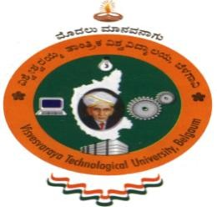

**A Database Management System Mini Project Report on**

**“Student Result Management System”**

Submitted in Partial fulfillment of the Requirements for the V Semester of the Degree of

**Bachelor of Engineering In**

**Computer Science & Engineering**

By

**SUGYAN ANAND MAHARANA (1CR17CS154)**

**PAVAN RAJKUMAR MAGESH**

**(1CR17CS090)**

**Under the Guidance of**

**Ms.Mariet Furtado**

**Asst Professor, Dept. of CSE**

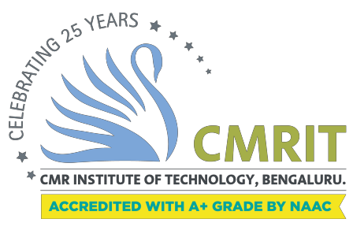

**DEPARTMENT OF COMPUTER SCIENCE AND ENGINEERING**

# CMR INSTITUTE OF TECHNOLOGY

### DEPARTMENT OF COMPUTER SCIENCE AND ENGINEERING



**CERTIFICATE**

This is to certify that the Database Management System Project work entitled **“Student Result Management System”** has been carried out by **Pavan Rajkumar Magesh(1CR17CS090)** and **Sugyan Anand Maharana(1CR17CS154)** bonafide students of CMR Institute of Technology in partial fulfillment for the award of **Bachelor of Engineering** in **Computer Science and Engineering** of the Visvesvaraya Technological University, Belgaum during the year **2019-2020**. It is certified that all corrections/suggestions indicated for Internal Assessment have been incorporated in the Report deposited in the departmental library. This DBMS Project Report has been approved as it satisfies the academic requirements in respect of project work prescribed for the said degree.

### ----------------------- ----------------------

Signature of Guide Signature of HOD

Ms. Mariet Furtado Dr. Prem Kumar Ramesh

Assistant Professor Professor, Head

Dept. of CSE, CMRIT Dept. of CSE, CMRIT

External Viva

Name of the examiners Signature with date

1.

2.